Kevin Rudd Kevin Rudd (1957–Present)

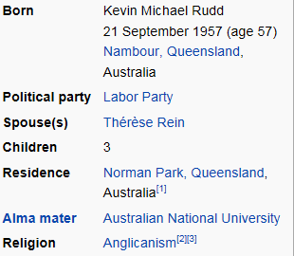
Kevin Rudd, Australia's 26th Prime Minister, held office from 3 December 2007 to 24 June 2010, and for 11 weeks in 2013. In 2001, he was appointed Shadow Minister for Foreign Affairs, with responsibility for international security added in 2003, and trade in 2005. Kevin Rudd became the 19th Leader of the Australian Labor Party in 2006, before becoming Prime Minister in 2007.
Labor won the 2007 election by a landslide, with a 23-seat swing in its favour, and Rudd was sworn in as the 26th Prime Minister of Australia on 3 December. The Rudd Government's first acts included signing the Kyoto Protocol and delivering an apology to Indigenous Australians for the Stolen Generations.
Kevin Rudd’s apology was regarded as a significant event in Australia’s history. It was intended to help bridge the gap between indigenous and non-indigenous Australians. His speech was heavily applauded and supported by all Australians.
In response to the global financial crisis, the government provided economic stimulus packages, and Australia was one of the few developed countries to avoid the late-2000s recession.
On 24 June 2010 he became one of the few leaders to be removed by their own party in their first term as prime minister. On 27 June 2013, the Governor-General again swore in Kevin Rudd as Prime Minister after he was voted Leader of the Parliamentary Labor Party. Following Labor's defeat in the September 2013 federal election, Kevin Rudd resigned from Parliament on 22 November 2013.
Kevin Rudd was federal member for Griffith (Queensland), and first entered Parliament in 1998.
