Sir Henry Parkes Sir Henry Parkes (1816–1896)

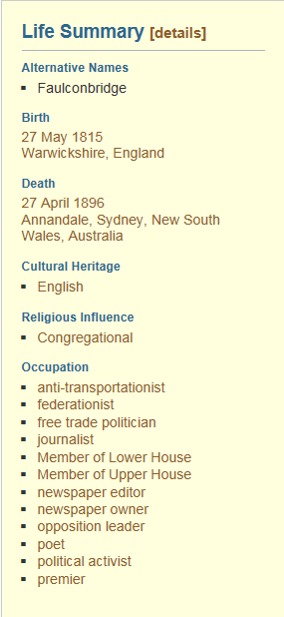
Henry Parkes was a politician and was premier of New South Wales five times. Born in England, Parkes had little schooling. He arrived in Australia in 1839, went into business and started a newspaper. He was interested in politics and wanted changes in the way New South Wales was governed. He was elected to the New South Wales Parliament in 1854 and helped introduce laws which improved hospitals and prisons and the lives of small farmers. Parkes began the first of his five terms as premier in 1872.

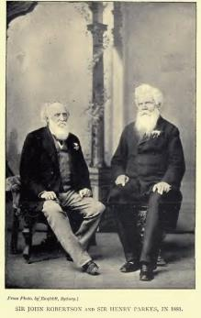
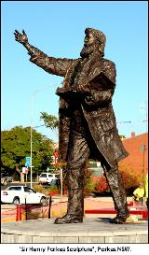
From the 1860's on, Parkes talked to people about the states joining together (federating). He was president of a convention (meeting) in 1891 to plan a constitution (set of rules) for a federated Australia. While this plan was not chosen, it was used later as a model for the final version. Parkes has been called 'The father of Australian federation'. The town of Parkes in New South Wales is named after him and his picture appears on stamps.
